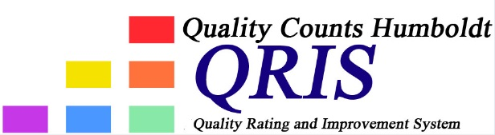

Quality Counts California (Infant-Toddler) Grant

Guidelines for earning a Professional Development Incentive
Incentives would be paid to individuals so owners and/or employees (listed on the license) of childcare programs would be eligible to apply. In addition, programs could earn a $500 incentive for raising their QRIS Tier level.
Incentives will be awarded based on hours of trainings attended and/or college classes completed (Can be one or the other, or a combination of both) See the Incentive Levels Chart below:

Incentive levels:
$1,500 75 training hours OR 5 Units of college courses leading to a degree
$1,200 60 training hours OR 4 Units of college courses leading to a degree
$900 45 training hours OR 3 Units of a college course leading to a degree
$600 30 training hours OR 2 Units of a college course leading to a degree
$300 15 training hours OR 1 Unit of a college course leading to a degree

Professional Development
Any Professional Development that individuals engage in must link to the QRIS Matrix and that program or individual’s Quality Improvement Plan. (Which, in turn, would be based on assessment scores and subsequent professional development plans and goals)

Documentation Required
Individuals can turn in documentation of a class or training completion (certificates, transcripts or grades, etc.) with their incentive request form. Since the grant started on July 1, 2020, participants will be able to count any trainings or classes attended since that date. Upon receipt of completion documents, the QRIS Coordinator will evaluate which Incentive Level an individual has earned.

Timeline for completion of Professional Development
All Professional development must be completed by May 1, 2021. Documentation can include certificates of completion, transcripts or letters from instructors.

